While I’m busy getting my AU classes in order, Jan Liska kindly provided this month’s sample app. He is also the author of the popular Drawing Compare app. Thanks Jan!
Find Orphaned Files is a quick and easy way to detect files that are not referenced by any other file. In other words, files with no files listed in the “Where Used” tab. To launch the app, just select a folder in Vault, right-click and choose the Find Orphaned Files command.
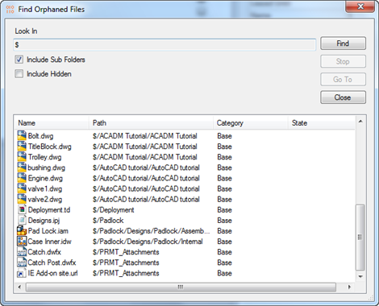
Requirements:
Vault Workgroup/Collaboration/Professional 2013
Click here to download the application
Click here to download the source code
As with all the samples on this site, the legal disclaimer applies.

